[Image of JSP in background]

Planning your visit - whether it’s your first time or your hundredth, here’s everything you need to enjoy your time at Jacob Smith Park

What to enjoy in Jacob Smith Park?
JSP is a precious green space close to the centre of Knaresborough. It’s a great spot for walking, getting closer to nature, enjoying the views, spending time with friends or just relaxing and watching the world go by.

Inside JSP
The park is a managed wild space with a network of paths cris-crossing its 30 acres and has a perimeter walk covering approximately three quarters of a mile. Some of the paths involve steeper climbs but these can be avoided by using other paths.

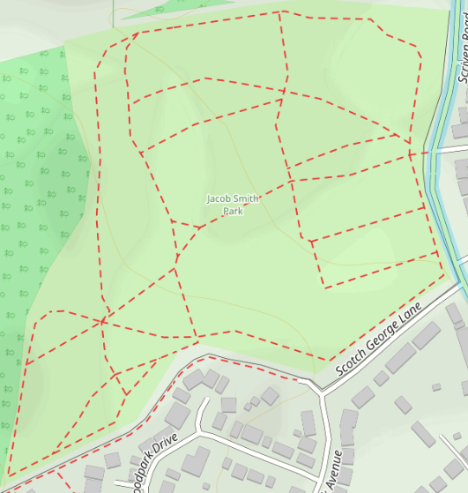


EDIT MAP TO JUST KEEP PARK AREA, ADD POSTION OF BENCHES AND ENTRANCE – see 2nd map below – can you tidy up the bench icons?








There are seven benches at various points around the park to rest or take in the beautiful views, which extend as far as the White Horse on the North York Moors. There is also a small recreational area near to the entrance for children to run around, play ball games and fly kites.

JSP has just one entrance. It is enclosed but there may be gaps in some perimeter fencing, so you should only let dogs off the lead if they are under control, in your sight and will come when called. Please ensure you clean up after your dog and dispose of waste in the bin near the park entrance.

Note: some paths, especially around the entrance, can be very muddy in winter or after heavy rain.

INSERT PHOTO OF PEOPLE SAT ON BENCHES (or something) – KM TO SOURCE

Wildlife (Make the header the link to wildlife)

There is a range of habitats throughout the park, including woods, meadow and grasslands, wetlands and veteran trees. These habitats support a rich and diverse variety of wildlife.

Children are encouraged to explore the park with a guided nature trail; this has a beautifully illustrated guide with notes to help children discover an exciting new world.

You can download the guide at Jacob Smith Park nature trail

Code of conduct (Make the header link to Code of Conduct?)
We request that all visitors to the park are respectful to others and follow the Jacob Smith Park Code of Conduct

Barbecues, open fires, cycling and horses are prohibited by North Yorkshire Council.

Where are we?
The entrance to Jacob Smith Park (JSP) is on Scriven Road:

Scriven Road, Scriven, Knaresborough HG5 9EJ (at the junction with Park Grove)

What3Words location reference: https://w3w.co/milder.suppose.plump

Street parking on the road is very limited and Police Community Support Officers regularly patrol the area.

The nearest toilet facilities at Conyngham Hall, approximately a 20-minute walk or 5-minute drive.

Conyngham Hall, Knaresborough HG5 9AY

Google map – park location
